IMS TEST

ENVIRONMENT

Sandbox: imsTest

Login: username + .imstest

Password: Salesforce Password

APPLICATION

Utilities Lightning App

SCOPE

Test full cycle uniform order, receipt, issue to employee and return.

Developed for use in Salesforce Lightning

PREREQUISITES

1. Basic knowledge using Lightning for Salesforce
2. All tests will be conducted using the Utilities Lightning app
3. Access to Global Action Vendor Order

TEST DATA

Employees

For a list of Employees from the Contacts tab open List View All Active SIS Employees and note the employee number.

Clothing Items for Processing

For a list of items that can be ordered run report: IMS Details by Type from folder: IMS Reports

And note the SIS Barcode

Billing Locations

For a Billing Location from Location Data Select List View All – Active Parent Jobcodes

And note the Location Data Name

Vendors

For a Vendor from Accounts Select List View Vendor – Uniforms and note the Account Name

Ship to Account

For a Ship to Account Select List View Clients from Accounts and note the Account Name

There are two ways to create a new vendor order. You can create a new order using the Global Action New Vendor Order or clone an existing order from by clicking the Uniform Vendor Order button.

TEST #1

CREATE NEW VENDOR ORDER USING GLOBAL ACTION

Concessions:

1. It would be desirable to dynamically display input fields based on prior selections, however Salesforce doesn’t have this feature in the standard object.
2. The Vendor Order Process is set to function for Transaction Status:
   1. New
   2. Ordered
   3. Shipped Complete
   4. Received Complete

Create New Vendor Order

1. Select Global Action Vendor Order

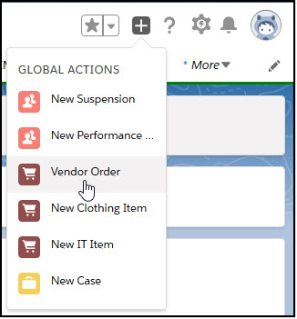

Note: you can maximize the Vendor Order window by clicking the arrows in the top right corner of the window.

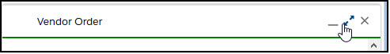

1. Create Vendor Order
   1. Vendor: Galls
   2. Employee: Gary Adams
   3. Billable: False
   4. Billable: Blank
   5. Stocking Facility: 26000 – Amazon SLU
   6. Ship To: Account
   7. Ship To Account: Amazon.com
   8. Ship To Contact: Blank
   9. Ship to Other: Blank
   10. Tax Rate: 0.0000%
   11. Click [Save]

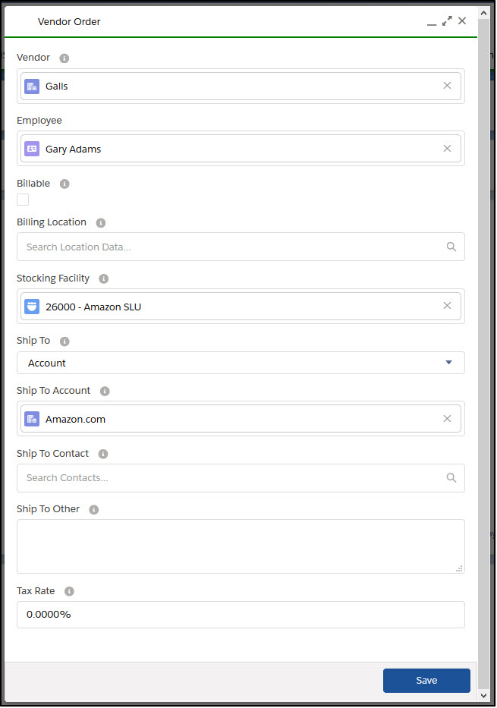

1. Go to Add Items to Order

CREATE NEW UNIFORM VENDOR ORDER FROM EXISTING ORDER

1. From Detail page of existing IMS – Transaction click [Uniform Vendor Order]

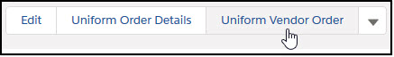

1. Update: Vendor
2. Update: Ship To Account
3. Update: Stocking Facility
4. Update: Billable
5. Update: Billing Location
6. Update Required Date if necessary

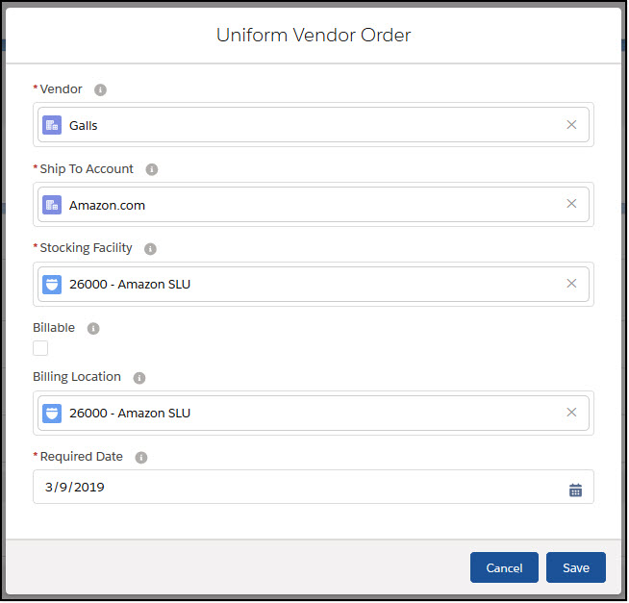

1. Click [Save]

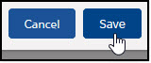

ADD ITEMS TO ORDER

Review Order Header

1. Select the IMS Transactions tab



1. Select the List View All – Employee Orders Today
2. Select the most recently created Vendor Order
3. Review the order for accuracy
4. The required date defaults to two days from the created date.

Add Items from IMS Transaction

1. Click [Uniform Order Details] to begin order process for each item

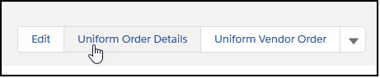

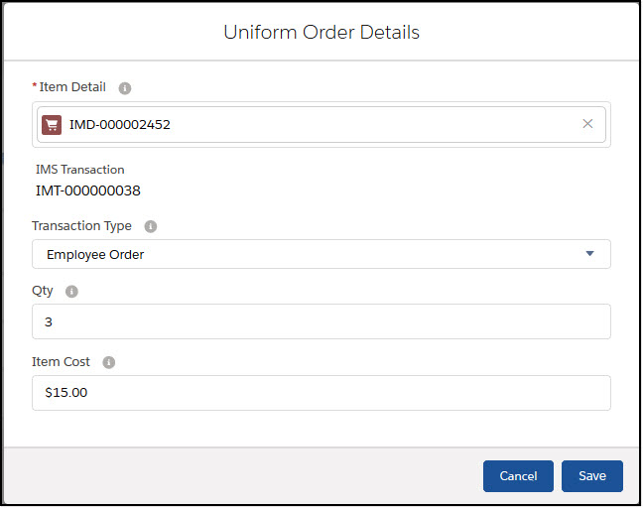

1. Order Shirts
   1. Item Detail: IMD-000002452 00002453
   2. Qty: 3
   3. Item Cost: $15.00
   4. Click [Save]
2. Order Pants
   1. Item Detail: IMD-000002470 00002471
   2. Qty: 2
   3. Cost: $25.00
   4. Click [Save]
3. Order Shoes
   1. Item Detail: IMD-000002476 00002477
   2. Qty: 1
   3. Item Cost: $45.00
   4. Click [Save]

Review Transaction Details from IMS Transaction Record

1. Click the Transaction Details tab

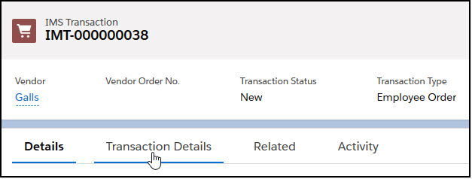

1. Select the Order Detail you want to review.

UPDATE TRANSACTION STATUS TO ORDERED

From the Transaction Record

1. Click [Edit]

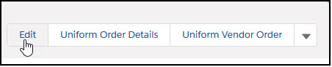

1. Update the Transaction Status to Ordered

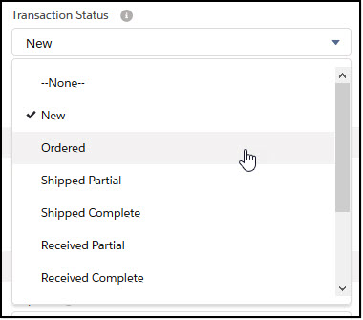

1. Click [Save]



Always keep in mind that updating the transaction status updates the details status.

1. In the Transaction Quantities Section the Qty Total, Qty On Order and Qty Balance will be updated.
2. In the Status Dates section the Order Date will be updated to the current date

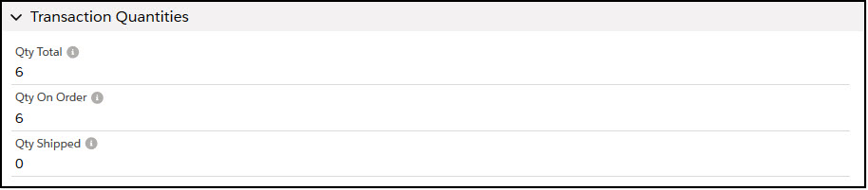

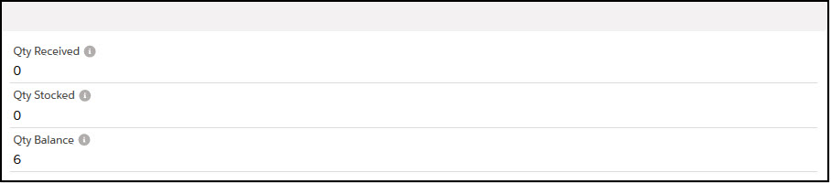

UPDATE TRANSACTION STATUS TO SHIPPED COMPLETE

Follow the same steps for updating the Transaction Status from above.

1. Click [Edit]
2. Update the Transaction Status to Shipped Complete
3. Click [Save]
4. Note in Transaction Quantities section the following changes:
   1. Qty On Order has been reduced to 0
   2. Qty Shipped = Qty Total
   3. Qty Balance = Qty Total
5. In the Status Date section the Shipped Date will be updated to the current date

UPDATE TRANSACTION STATUS TO RECEIVED COMPLETE

Follow the same steps for updating the Transaction Status from above.

1. Click [Edit]
2. Update the Transaction Status to Received Complete
3. Click [Save]
4. Note in Transaction Quantities section the following changes:
   1. Qty Shipped has been reduced to 0
   2. Qty Balance has been reduced to 0
   3. Qty Received = Qty Total
   4. Qty Stocked = Qty Total
5. In the Status Date section the Received Date and Stock Date fields will be updated to the current date

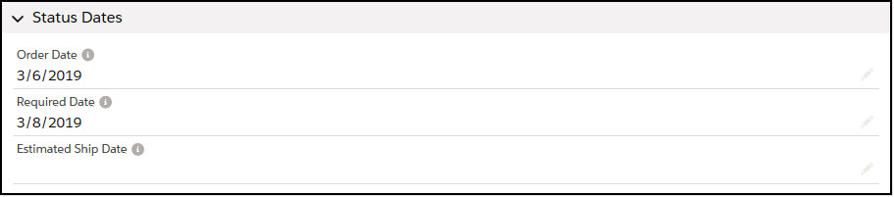

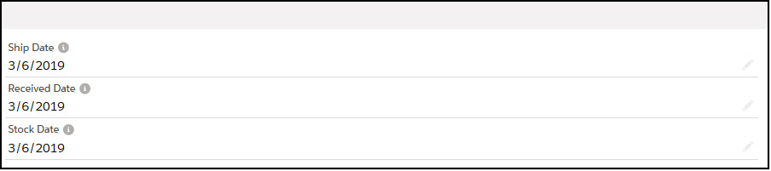

ISSUE TO EMPLOYEE

Concessions

1. In order to link a Salesforce Visualflow to a List View, a list view other than Most Recent must be selected.
2. Because of the inconsistent length of Vendor SKU numbers we can’t auto advance the page for Issuing and Returning Items.
3. Using the IMS Transaction flow there is a limit of dynamic items that can be displayed in a picklist. If a Stocking or Billing location doesn’t exist in the picklist, Select the defaults and fix these values on the actual record that will have all locations available.
4. With this release the confirmation page for issue reads “3 items issued”. This needs to be changed to a more generic response “Items successfully issued.”

Issue Items to an Employee

1. To issue items to an employee start by clicking on the IMS Transactions tab.



1. Select any List View besides Recently Viewed
2. Click [IMS Transaction]

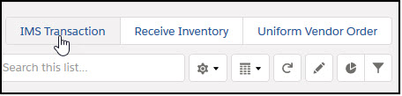

1. Transaction Type: Issue
2. Employee Number: 36485
   1. Note: The page will auto advance after the 5th character is entered in the Employee Number field.

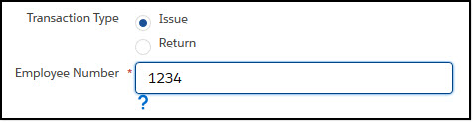

1. Item SKU: 00002453

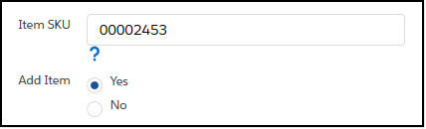

1. Click [Next]

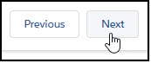

1. Repeat steps 5 and 6 for each additional item.
2. Item SKU: 00002471
3. Click [Next]
4. Item SKU: 00002477
5. Click [Next]
6. After Last Item click [Next] to complete issuing items.
7. To Issue the items select Issue Items: Yes

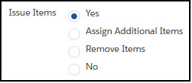

1. Click [Next]

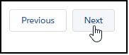

1. Issue Date: Default Today
2. Billable: Default Checked
3. Stocking Location: Default Employee Master Job Code (Can be changed)
4. Note: If the location isn’t in the drop down, select the default and fix on the record that is created for this employee issue.
5. Billing Location: Default Employee Master Job Code (Can be changed)
6. Add notes if necessary.

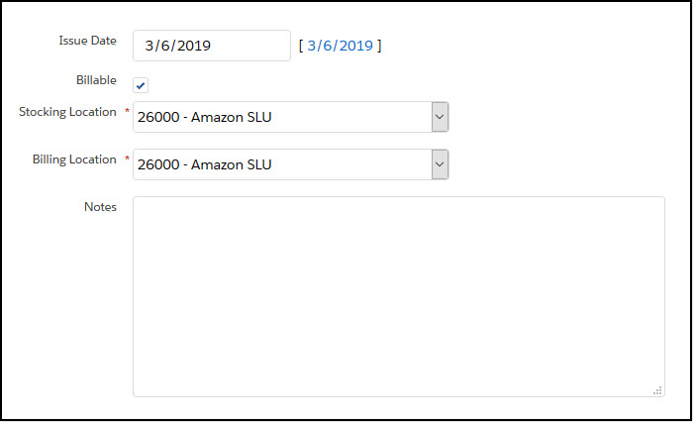

1. Click [Next]
2. The summary page indicates the items were issued

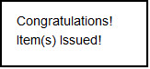

1. Click [Finish]

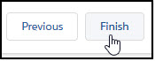

Review Employee Item Issue

1. Select the IMS Transactions tab
2. Select the most recently created IMS Transaction

RETURN ITEMS FROM EMPLOYEE

Return Items From an Employee

1. To return items from an employee start by clicking on the IMS Transactions tab.



1. Select any List View besides Recently Viewed
2. Click [IMS Transaction]



1. Transaction Type: Return
2. Employee Number: 36485
   1. Note: The page will auto advance after the 5th character is entered in the Employee Number field.

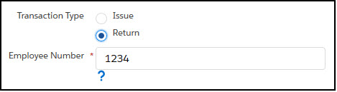

1. Item SKU: 00002453



1. Click [Next]



1. Repeat steps 5 and 6 for each additional item.
2. Item SKU: 00002471
3. Click [Next]
4. Item SKU: 00002477
5. Click [Next]
6. After Last Item click [Next] to complete returning items.
7. A confirmation screen will show all items returned in this transaction.
8. Click [Next]



1. Click [Next] to return to the Inventory Management System page